**Lab 1: HTML Basics**

***LAB : 1***

**Problem 1: Resume Creation**

**Problem Statement:**

**Create your resume page as per the format shown in the figure that follows.<!DOCTYPE HTML>**

<HTML>

<HEAD>

<TITLE> Curriculam Vitae </TITLE>

</HEAD>

<BODY>

<H1 align="center"> RESUME</H1>

<HR>

<i>Praseeda Prasannan<br>

59/4, Shiv nagar,<br> Gandhi Mandi<br> Panipat, Haryana

Contact Number:8053785033<br>

<b>Email ID: </b>Praseedaprasannan9@gmail.com<br></i>

<HR>

<h2>Educational qualifications:</h2>

<TABLE border="0" >

<TR>

<TH>Qualification</TH>

<TH>Institute</TH>

<TH>University/Board</TH>

<TH>Marks(%)</TH>

<TH>Year of Passing</TH>

</TR>

<TR>

<TD>B.TECH.</TD>

<TD>P.I.E.T</TD>

<TD>KUK</TD>

<TD>79.55%</TD>

<TD>2017</TD>

</TR>

<TR>

<TD>12th</TD>

<TD>S.I.S</TD>

<TD>CBSE</TD>

<TD>75.6%</TD>

<TD>2013</TD>

</TR>

<TR>

<TD>10th</TD>

<TD>S.I.S</TD>

<TD>CBSE</TD>

<TD>89%</TD>

<TD>2011</TD>

</TR>

</TABLE>

<h2>Skill Set:</h2>

<p><b>Operating System: </b>Windows 9'x, DOS <br>

<b>Language: </b>c/c++<br>

<b>Front End:</b> Netbeans, Eclipse<br>

<b>DBMS: </b>SQL Server, MySQL</p>

<h2>Achievements:</h2>

<OL type="i">

<li>Certified from IIT Bombay for C/C++ Training.</li>

<li>Certified from IIT Bombay for Java Training.</li>

<li>Review Paper Published and ceritified by ITCITE</li>

</OL>

<h2>Strengths:</h2>

<UL type="square">

<li>Dedicated to the work.</li>

<li>Adaptive to environment.</li>

<li>Sincere to my aim.</li>

</UL>

<h2>Personal Information:</h2>

<UL type="square">

<li><b>Name:</b>Praseeda Prasannan </li>

<li><b>Contact Number:</b>8053785033 </li>

<li><b>Email ID:</b>Praseedaprasannan9@gmail.com </li>

<li><b>Father's Name:</b>Prasannan Kumar </li>

<li><b>DOB:</b>20th Jan, 1995 </li>

<li><b>Permanent Address:</b>169, Veliyanadu P.O., Alleppy, Kerala </li>

<li><b>Correspondance Address:</b>Shiv Nagar, Panipat, Haryana </li>

<li><b>Nationality:</b>Indian </li>

<li><b>Languages Known:</b>Hindi, English, Malayalam</li>

</UL>

</BODY>

</HTML>

**OUTPUT:**

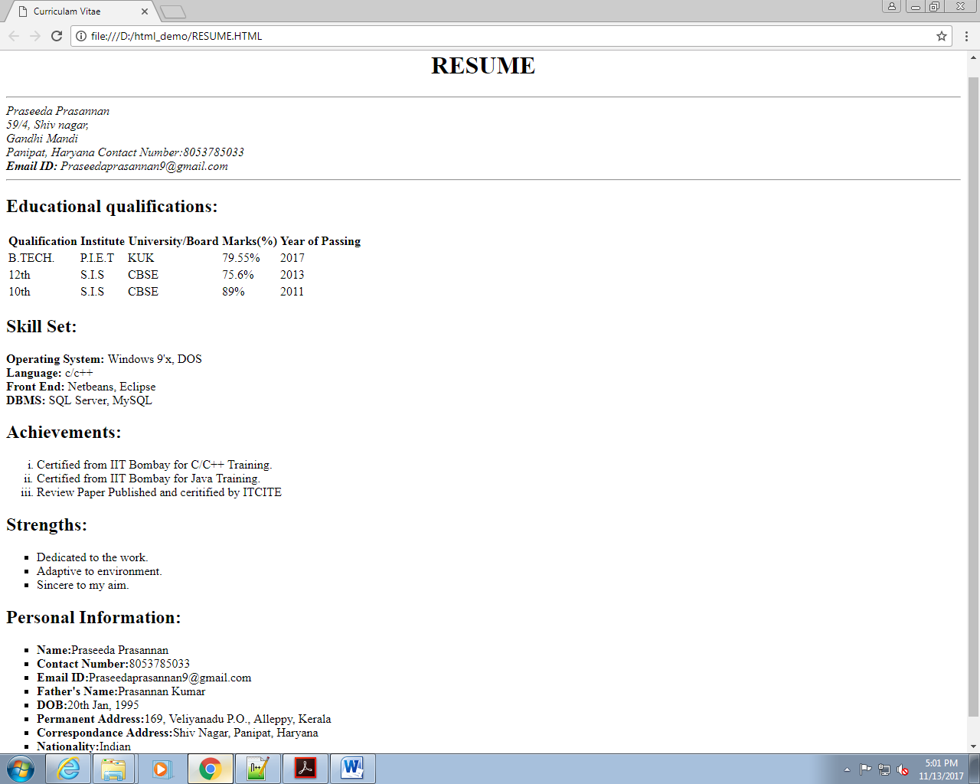

**Lab 2: Creating Tables**

***LAB : 2***

**Problem Statement:**

**Create a html page*.* When this page is opened in a browser, it should**

**appear as shown in the following figure**

<!DOCTYPE HTML>

<HTML>

<HEAD>

<TITLE> PRODUCT TABLE</TITLE>

</HEAD>

<BODY>

<TABLE border="1" width="50%" cellspacing="5" cellpadding="5">

<TR>

<TH style="background-color:SKYBLUE">Product</TH>

<TH style="background-color:SKYBLUE">Price</TH>

<TH style="background-color:SKYBLUE">Quantity</TH>

<TH style="background-color:SKYBLUE">Amount</TH>

</TR>

<TR>

<TD>P001</TD>

<TD>1000.00</TD>

<TD>12</TD>

<TD>12000.00</TD>

</TR>

<TR>

<TD>P002</TD>

<TD>1200.00</TD>

<TD>10</TD>

<TD>20000.00</TD>

</TR>

<TR>

<TD>Total</TD>

<TD>3000.00</TD>

<TD>22</TD>

<TD>32000.00</TD>

</TR>

</TABLE>

</BODY>

</HTML>

**OUTPUT:**

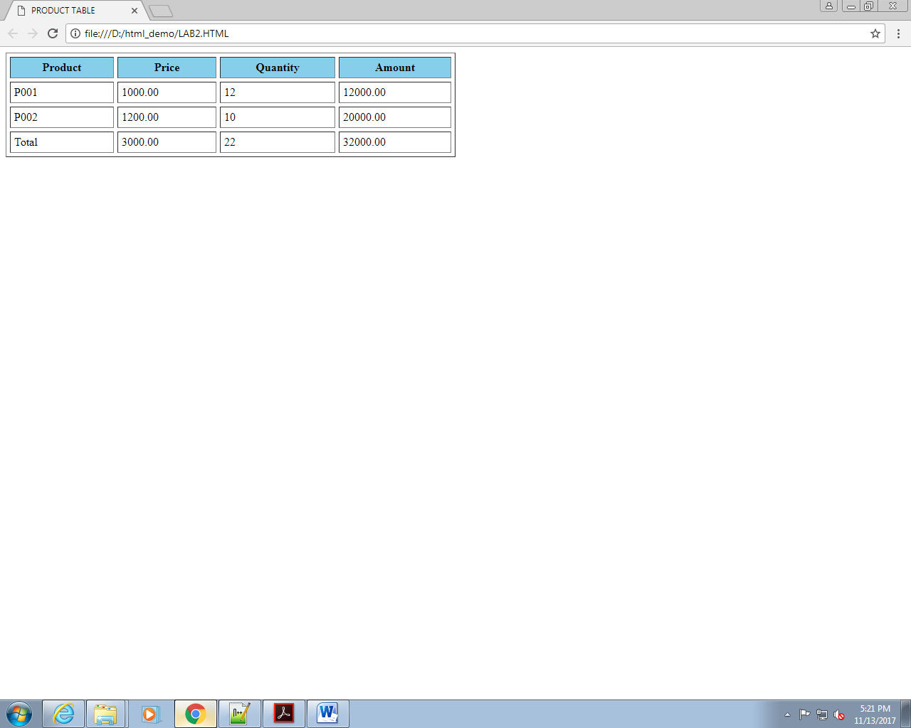

**Problem 3: Calendar**

**Problem Statement:**

Design a web page to display a calendar for a month using html table.

<!DOCTYPE HTML>

<HTML>

<HEAD>

<TITLE> TABLE</TITLE>

</HEAD>

<BODY>

<TABLE border="1" width="50%" cellspacing="5" cellpadding="5">

<TR><TH COLSPAN="7" style="background-color:YELLOW">JANUARY</TH></TR>

<TR style="background-color:MAGENTA">

<TH>SUN</TH>

<TH>MON</TH>

<TH>TUE</TH>

<TH>WED</TH>

<TH>THU</TH>

<TH>FRI</TH>

<TH>SAT</TH>

</TR>

<TR>

<TD></TD>

<TD></TD>

<TD></TD>

<TD></TD>

<TD></TD>

<TD style="background-color:YELLOW">1</TD>

<TD style="background-color:AQUA">2</TD>

</TR>

<TR>

<TD style="background-color:GREEN">3</TD>

<TD>4</TD>

<TD>5</TD>

<TD>6</TD>

<TD>7</TD>

<TD>8</TD>

<TD style="background-color:AQUA">9</TD>

</TR>

<TR>

<TD style="background-color:GREEN">10</TD>

<TD>11</TD>

<TD>12</TD>

<TD>13</TD>

<TD>14</TD>

<TD>15</TD>

<TD style="background-color:AQUA">16</TD>

</TR>

<TR>

<TD style="background-color:GREEN">17</TD>

<TD>18</TD>

<TD>19</TD>

<TD>20</TD>

<TD>21</TD>

<TD>22</TD>

<TD style="background-color:AQUA">23</TD>

</TR>

<TR>

<TD style="background-color:GREEN">24</TD>

<TD>25</TD>

<TD>26</TD>

<TD style="background-color:YELLOW">27</TD>

<TD>28</TD>

<TD>29</TD>

<TD style="background-color:AQUA">30</TD>

</TR>

<TR>

<TD style="background-color:GREEN">31</TD>

<TD></TD>

<TD></TD>

<TD></TD>

<TD></TD>

<TD></TD>

<TD style="background-color:AQUA"></TD>

</TR>

</TABLE>

</BODY>

</HTML>

**OUTPUT:**

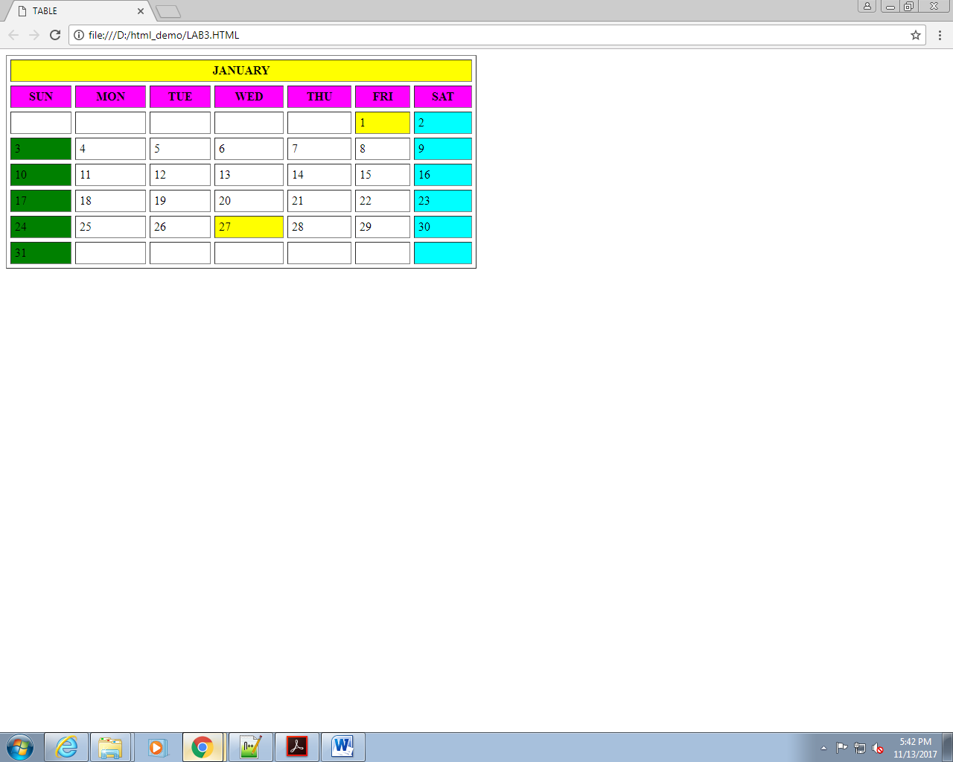

**Lab 3: Working with Lists**

**Problem 2: Subjects**

**Create a web page to display a list as shown in the figure that follows.**

<!DOCTYPE HTML>

<HTML>

<HEAD>

<TITLE> List Tags </TITLE>

</HEAD>

<BODY>

<h2> DISPLAY THE LIST OF SUBJECTS USING LIST</h2>

<ol TYPE="1">

<li>Language</li>

<ol type="i">

<li>English</li>

<ol type="A">

<li>Prose</li>

<li>Poetry</li>

</ol>

<li>Hindi</li>

<ol type="A">

<li>Prose</li>

<li>Poetry</li>

</ol>

<li>Maths</li>

<ol type="A">

<li>Prose</li>

<li>Poetry</li>

</ol>

</ol>

<li>Social Science</li>

<ol type="i">

<li>History</li>

<li>Geography</li>

</ol>

<li>Science</li>

<ol type="i">

<li>Physics</li>

<ol type="A">

<li>PART I</li>

<li>PART II</li>

</ol>

<li>Chemistry</li>

<ol type="A">

<li>Organic</li>

<li>Inorganic</li>

</ol>

<li>Biology</li>

<ol type="A">

<li>Botany</li>

<li>Zoology</li>

</ol>

</ol>

<li>Maths</li>

<ol type="i">

<li>Algebra</li>

<li>Geometry</li>

</ol>

</OL>

</BODY>

</HTML>

**Output:**

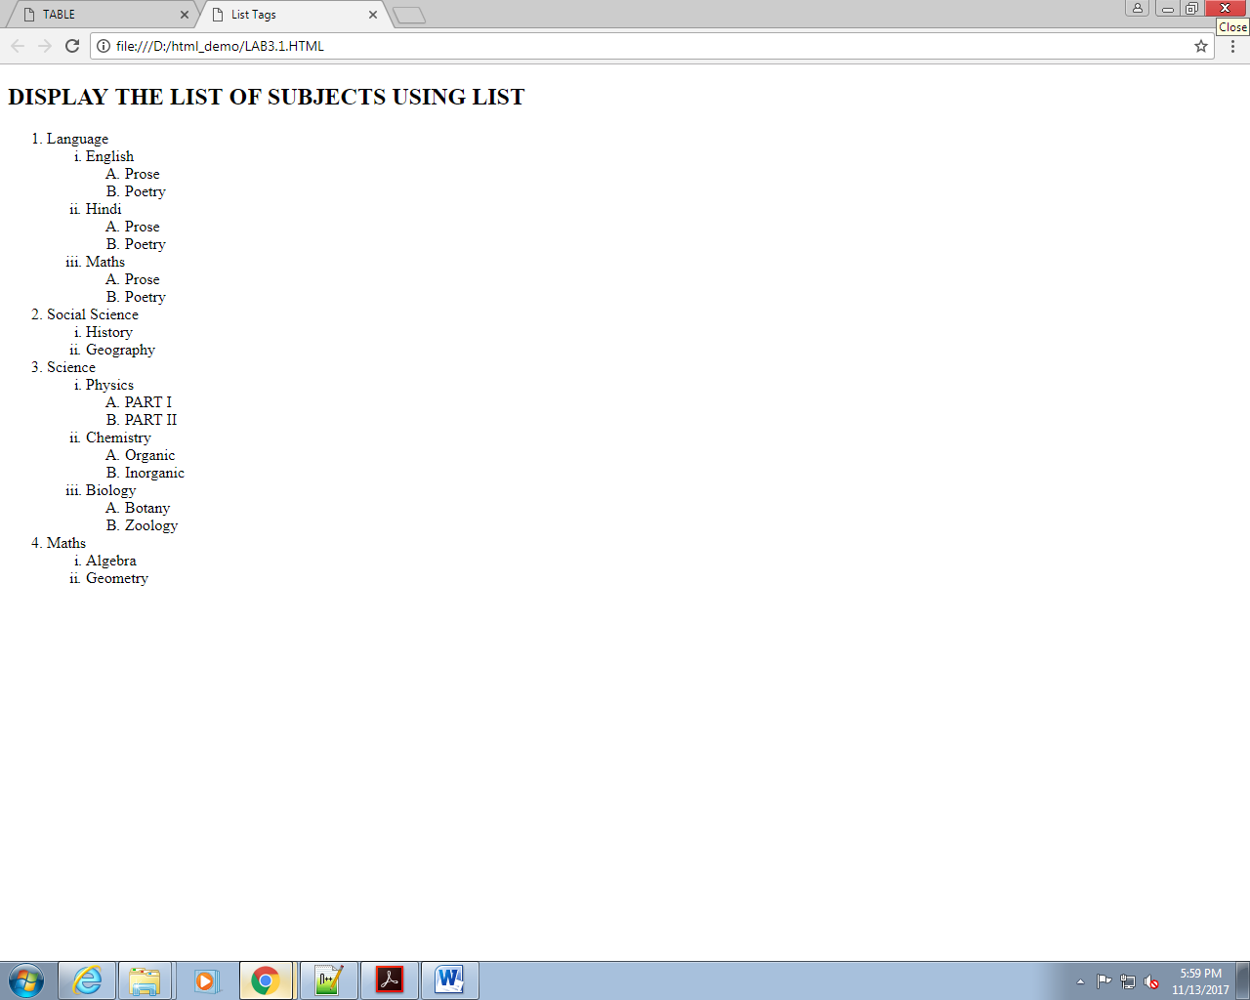

**Lab 4: Working with Links**

**Problem 2: Employee Details <<To Do>>**

**Problem Statement:**

**Design a simple home page for a company to display employee details as given below.**

<!DOCTYPE HTML>

<HTML>

<HEAD>

<TITLE> hyperlinks</TITLE>

</HEAD>

<BODY>

<TABLE border="1" width="100%" cellspacing="10" cellpadding="10">

<TR>

<TH>Empcode</TH>

<TH>EmpName</TH>

<TH>DeptCode</TH>

<TH>Experience</TH>

</TR>

<TR>

<TD>1001</TD>

<TD>Kiran Rao</TD>

<TD><a href="mumbai.html" target="_blank"> 10 </TD>

<TD>8 Yrs.</TD>

</TR>

<TR>

<TD>1002</TD>

<TD>Aamir Khan</TD>

<TD><a href="pune.html" target="_blank"> 20 </TD>

<TD>8 Yrs.</TD>

</TR>

<TR>

<TD>1003</TD>

<TD>Ishita Shah</TD>

<TD><a href="chennai.html" target="_blank"> 30 </TD>

<TD>8 Yrs.</TD>

</TR>

</TABLE>

</BODY>

</HTML>

**Output:**

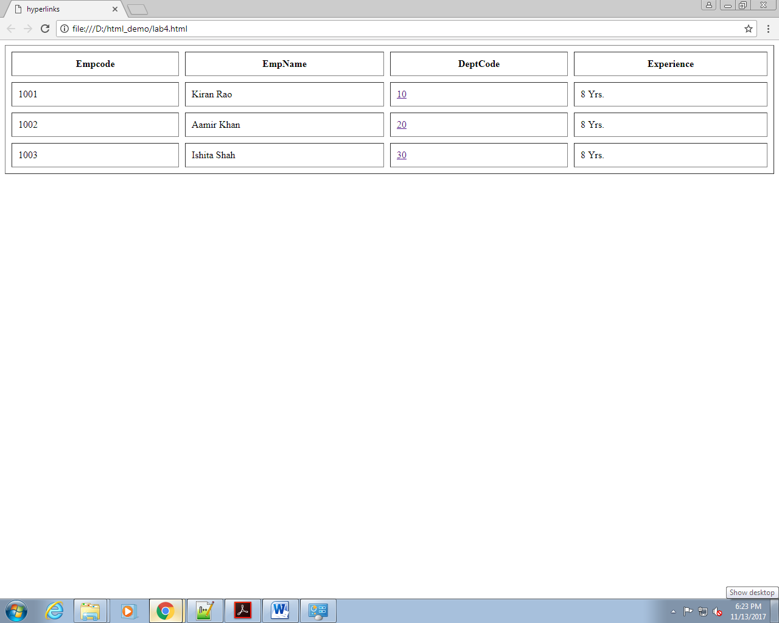

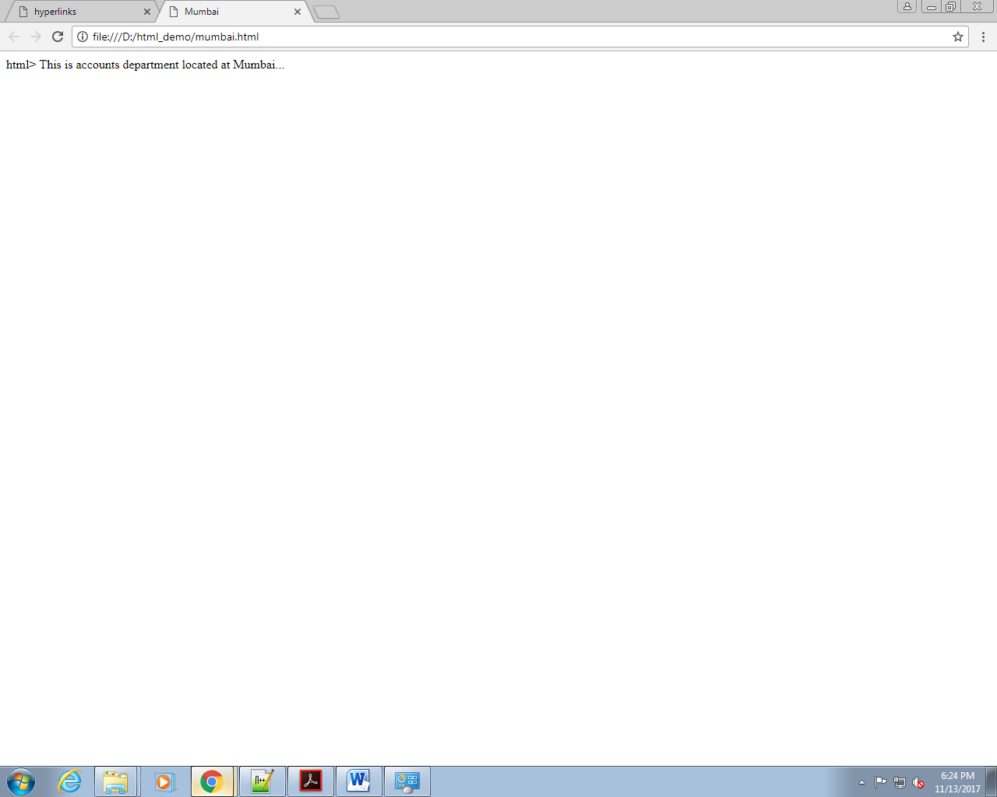

**Lab 5: Image Handling**

**Problem 1: Images with Clickable Areas <<To do>>**

**Problem Statement:**

**Create a web page with some images as shown in following figure:**

<!DOCTYPE HTML>

<HTML>

<HEAD>

<TITLE> image </TITLE>

</HEAD>

<BODY>

<table bordercolor="red">

<tr>

<td><img src="C:\Users\praspras\Downloads\1..jpeg" alt="image 1" width="600px" height="200px"\></td>

<td> SPRING</td>

</tr>

<tr>

<td><img src="C:\Users\praspras\Downloads\2.jpg" alt="image 2" width="600px" height="200px"\></td>

<td>RAINY</td></tr>

<tr>

<td><img src="C:\Users\praspras\Downloads\3.jpg" alt="image 3" width="600px" height="200px"\></td>

<td>SUMMAR</td>

</tr>

<tr>

<td><img src="C:\Users\praspras\Downloads\4.jpg" alt="image 4" width="600px" height="200px"\></td>

<td>WINTER</td></tr>

</table>

</BODY>

</HTML>

**OUTPUT:**

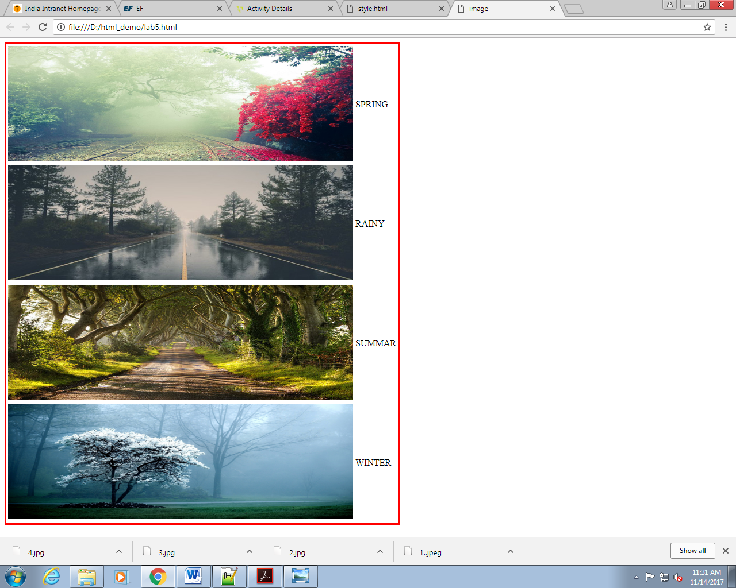

**Lab 6: Working with Frames**

**Lab 7: HTML Forms for User Input**

**Problem 2: Employee Details <<To Do>>**

**Problem Statement:**

**Design a web page *prob2.html* to accept the following employee details:**

**• Employee Name (Max 20 characters).**

**• Employee Code (Max 4 characters).**

**• Department (Use radio buttons).**

**• Date of Join (Use the format dd/mm/yyyy).**

**• Address.**

**• Training programs attended (Use check boxes).**

**• Training programs need to attend (Use select box).**

**• Send the information at** [**empinfo@capgemini.com**](mailto:empinfo@capgemini.com)**.**

<!DOCTYPE HTML>

<HTML>

<HEAD>

<TITLE> MOVIE FEEDBACK FORM </TITLE>

<style>

</style>

</HEAD>

<table border="1" width="50%" bgcolor="#6CD3F7">

<form>

<tr>

<td><label for="txttitle">Name:</label></td>

<td><input type="text" id="txtname" name="name" maxlength="30" size="20"/></td>

</tr>

<tr>

<td><label for="txtgenre">Employee Code:</label> </td>

<td><input type="text" id="txtcode" name="code" maxlength="5" size="4"/></td>

</tr>

<tr>

<td><label>Department: </label> </td>

<td><label> <input type="radio" id="rbadmin" name="admin"/>Admin<br>

<label> <input type="radio" id="rbhr" name="hr"/>HR<br>

<label> <input type="radio" id="rbtech" name="technical"/>Technical<br>

<label> <input type="radio" id="rbacnts" name="accounts"/>Accounts<br>

</label></td></tr>

<tr>

<td><label for="txtdoj">Date of Joining:</label></td>

<td >

<select id="date" name="date">

<option> 1</option> <option> 2</option>

<option> 3</option> <option> 4</option>

<option> 5</option> <option> 6</option>

<option> 7</option> <option> 8</option>

<option> 9</option> <option> 10</option>

<option> 11</option> <option> 12</option>

<option> 13</option> <option> 14</option>

<option> 15</option> <option> 16</option>

<option> 17</option> <option> 18</option>

<option> 19</option> <option> 20</option>

<option> 21</option> <option> 22</option>

<option> 23</option> <option> 24</option>

<option> 25</option> <option> 26</option>

<option> 27</option> <option> 28</option>

<option> 29</option> <option> 30</option>

<option> 31</option>

</select>

<select id="month" name="month">

<option> Jan</option> <option> Feb</option>

<option> Mar</option> <option> Apr</option>

<option> May</option> <option> Jun</option>

<option> Jul</option> <option> Aug</option>

<option> Sep</option> <option> Oct</option>

<option> Nov</option> <option> Dec</option>

</select>

<select id="year" name="year">

<option> 2001</option> <option> 2002</option>

<option> 2003</option> <option> 2004</option>

<option> 2005</option> <option> 2006</option>

<option> 2007</option> <option> 2008</option>

<option> 2009</option> <option> 2010</option>

<option> 2011</option> <option> 2012</option>

<option> 2013</option> <option> 2014</option>

<option> 2015</option> <option> 2016</option>

<option> 2017</option> <option> 2018</option>

</select><br>

dd &nbsp;&nbsp;&nbsp;&nbsp;&nbsp; mm &nbsp;&nbsp;&nbsp;&nbsp;&nbsp; yyyy</td>

</tr>

<tr><td><label for="txtaddress">Address: </label></td>

<td><textarea rows="6" cols="30" id="txtaddress" name="address" style="overflow:scroll;"></textarea></td>

</tr>

</tr>

<tr><td><label>Training Program Attended: </label></td>

<td><label> <input type="checkbox" id="chk1" name="html" />HTML/DHTML</br>

<label> <input type="checkbox" id="chk2" name="java" />Java</br>

<label> <input type="checkbox" id="chk3" name="clients" />Client/Server</br>

<label> <input type="checkbox" id="chk3" name="net" />.NET

</label></td></tr>

<tr>

<td><label for="txttrain">Training program need to attend:</label></td>

<td >

<select id="program" name="program">

<option> Javascript</option>

<option> CSS</option>

<option> JQuery</option>

<option> SAP/ABAP</option>

<option> Pseudocode</option>

</select></td>

</tr>

<tr><td><label>Send the information at: </label> </td>

<td ><a href="empinfo@capgemini.com.">empinfo@capgemini.com.</a></td></tr>

</form>

</table>

</BODY>

</HTML>

**OUTPUT:**

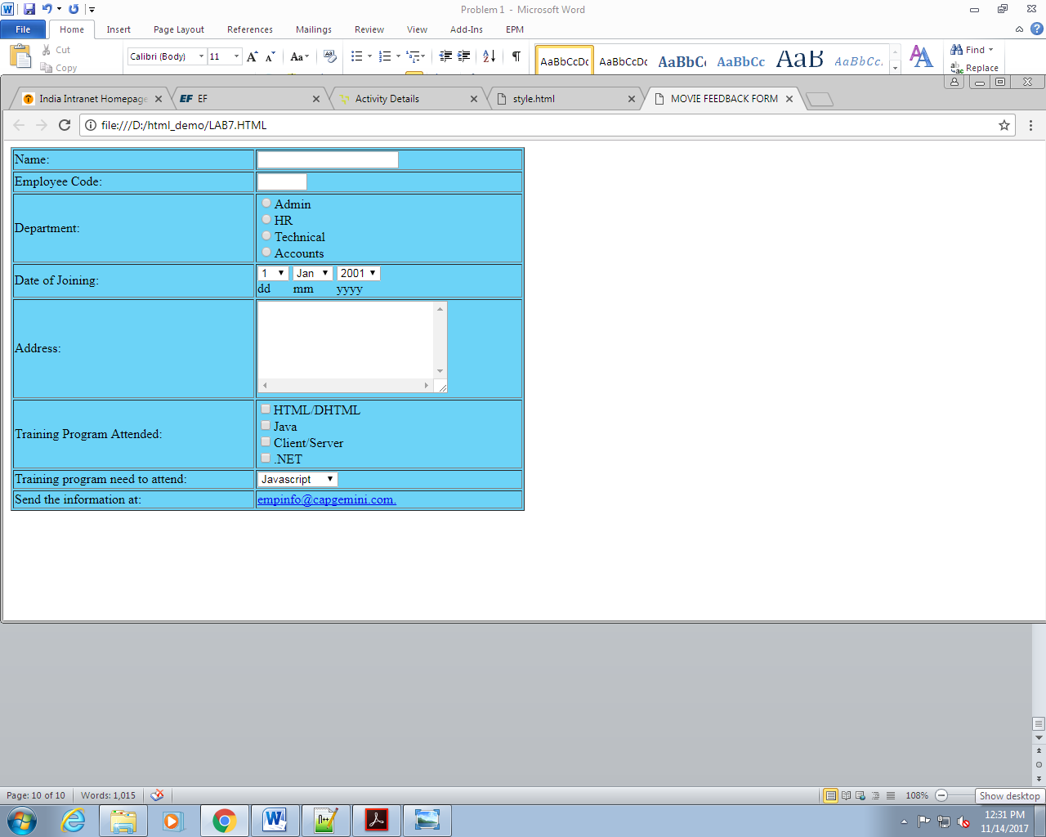

**Lab 8: New Form Elements**

**Problem 2: Candidate Details**

**Problem Statement:**

**Design a web page StudentInfoForm.html to accept the following student details:**

**1. Name (Accept only characters , Max 15 characters )**

**2. Password (Max 15 characters)**

**3. Phone number(Accept 10 digits)**

**4. Gender (Make use of radio button)**

**5. Date of Birth (Make use of date field and date of birth should not be greater than current date)**

**6. Email (Accept valid Email)**

**7. Highest Qualification (Make use of datalist to populate data like B.Tech, M.Tech, MBA, MCA,**

**MSc, MA, BSC..)**

**8. Courses interested in (Make use of check box)**

**9. Comments to mention regarding Degree / External Certificates (Make use of textarea)**

**10. Uploading Degree / External certificates (Make use of file input type)**

**11. Use Placeholders to describe the type of input.**

**12. All fields marked (*) are mandatory**